Assessment Instructions

Task 1 – Completing Member Class
In this task you need to complete the definition of the Member class which inherits from the provided class Person. Using the class diagram as a guide, add an appropriate instance variable and an appropriate method. (You might want to look at the expected output in testHarness1 to help you code the method).
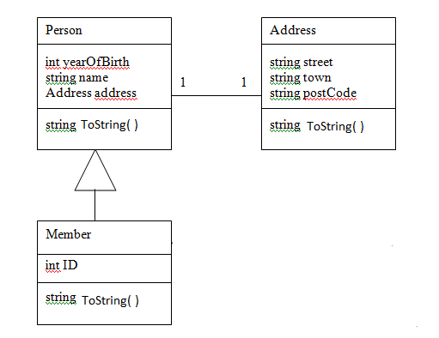
You should also code two constructors
public Member(String strn, string strst, string strtwn, string strpc, int yr,int mid)
These correspond to the member’s name, street, town, postcode, year of birth and id. Remember the constructor will need to call the base constructor!
public Member()
This overridden default constructor should set the id to 0 and call the base default constructor.
Make sure your Member class is appropriately commented using the xml style commenting.
Once you have completed this, uncomment the call to testHarness1() in the file program.cs and run the test. The code may need to be adapted to ensure it passes the test (see testing documentation).

Task 2 – Adding Members to the Library

In this task you will start to code the Library class so that it can support Members – do not worry about Stock at this stage.
Library
List<Member> members
void addMember(string nm, int yr, string St, string Twn, string strpc)
void listMembers( )

Member
int ID
string ToString( )

Using the class diagram above, add appropriate attributes and complete the shown methods. You may find the sequence diagrams in the design documentation useful here.
The Library constructor will also need edited so that it creates a new List<Member> for the members.
When a new Member is added to the library, the members id should be set to one more than the current size of the List containing the members (The standard List class has a property that returns the number of objects currently in a List).
The listMembers method should list the members on the Console window.
Make sure the methods and attribute are appropriately commented using the xml style commenting.
Once you have completed this, uncomment the call to testHarness2() in the file program.cs and run the test. The code may need to be adapted to ensure it passes the test (see testing documentation).

Task 3 – Stock Hierarchy
In this task, you need to add a new classes Stock, Book and Journal in a new file called Stock.cs. You need to complete these classes from scratch as shown in the class diagram below. Remember you will need to import appropriate standard class libraries to support DateTime structures.

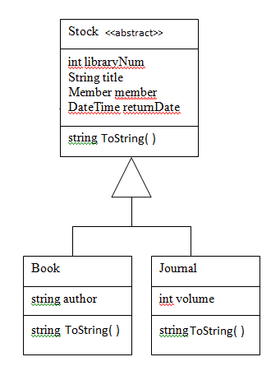
You also need to add the following constructors - note returnDate should be left as default value (i.e. do not set in constructor) and member should be set to null.
public Stock(int intid,string strtitle)
public Journal(int intid, string strtitle, int vol)
: base(intid,strtitle)
public Book(int intid, string strtitle, string strauthor)
: base(intid,strtitle)
You might want to look at testHarness3 to get an idea of the expected output from the ToString() methods.
You should also add two public setter and getter properties to the Stock class called
public string Title
public int ID

Task 3 Continued
In this second part of task 3, you will add code to the Library class that will allow the Library to add and view stock.
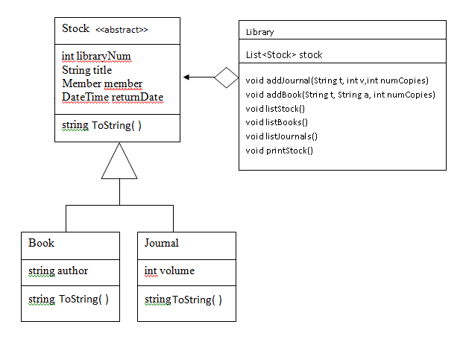
- Add the instance variable stock and update the Library constructor so that stock is set to a new list of Stock. (e.g. use generic List class)
- Complete the code for the addBook and addJournal methods. The sequence diagrams in the design documentation show how these should be coded – the stock ID should be set to one more than the number of Stock objects currently stored in the List<Stock> stock.
- Complete the code for the listStock and listJournals methods. The sequence diagrams in the design documentation show how these should be coded – you may also want to look at the commented out code for listBooks (remember to uncomment this!).
- Complete the code for the printStock method – this should send similar output to listStock to a text file whose name is passed in as an argument to the method. The sequence diagram should help as will previous examples using text files in the SimpleBank scenario.
Make sure the methods and attribute are appropriately commented using the xml style commenting.
Once you have completed this, uncomment the call to testHarness3() in the file program.cs and run the test. The code may need to be adapted to ensure it passes the test (see testing documentation).

Task 4 – Borrowing and Returning Stock
In this task you need to add the following additional methods to your Library class and Stock classes.
Library

void borrow( int memID, int stockID)
void returnStock( int stockID)
Stock findStock(int stockID)
Member findMemberByID(int id)
Member findMemberByName(string n)

Stock

void borrow( Member m)<<abstract>>
void returnStock ()

Book

void borrow(Member m)

Journal

void borrow(Member m)

Stock Class
Add an abstract method borrow – you need to override this in Book and Journal
Add returnStock method – this should throw an Exception if not on loan (member instance variable is null) or should set member instance variable to null.
Book and Journal
Override the borrow method so that the member attribute is set to the argument passed in as a parameter. The return date should be set to 14 days from the current date for Books and 2 days from the current date for Journals
The ToString method should be edited so that if a stock object is on loan (member set) then the method should also display the member loaned to and the return date.
Library
findMemberByID should simply be uncommented and findMemberByName coded by you.
findStock(int id) should search for a Stock and return the Stock object if present. If not it should throw an Exception.
borrow should use the two helper methods to find the Member and Stock and then call the Stock borrow method
returnStock should use the appropriate helper method to find the Stock and then call the Stock returnStock method
Once you have completed this, uncomment the call to testHarness4() in the file program.cs and run the test. The code may need to be adapted to ensure it passes the test (see testing documentation).

Task 5 PartialAcceptance Test
Comment out test harnesses 1 to 4 and then uncomment the call to the Windows form. You also need to go into the files frmLibrary, ReturnDialog and BorrowDialog and uncomment where indicated.
The partial acceptance test tests that when new members are added that they are validated by the following criteria.
Name – must have a name
YearOfBirth – must be a numeric value between 1920 and todays year
Street – must have a street
Town – must have a town
Postcode – must have a postcode between 6 and 8 characters long
The partial acceptance test should then be run and should show some errors in the validation of new Members.
You should complete and fix the “private void btnUpdate_Click(object sender, EventArgs e)” event handler in the file FrmLibrary.cs and then re-run the partial acceptance test showing that the program now works.

Task 6 Technical Manual

Project Brief

Specification document

Use Case Realisation documentation from tasks 1 to 4

Acceptance Test results task 5

Code listings for all classes (the code should have appropriate internal documentation)

XML documentation

Task 6 User Manual

This should consist of

Installation Requirements and Guide (a basic installation guide!)
User Guide (procedures for start-up and use of the software and which includes a list of error messages and their resolution)

Assessment Submittal

You should submit

The Technical Manual

The User Manual

An Electronic copy of the completed application

The assessment sheets
Testing Documentation
The classes should be tested as they are developed and the appropriate test harness run to ensure the classes support the expected behaviour at the end of each task development. The completed application should be tested using the given acceptance task after all of the development tasks have been completed.

Test Harness 1.

Expected Output
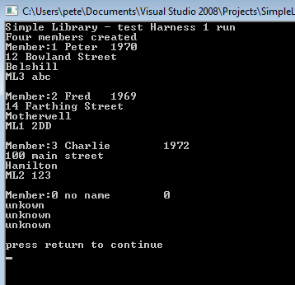
Date Test Run ________________________
Test Passed / Failed ________________________
Name of tester ________________________

Attach a copy of the output from your program that should be similar to the one above.

Test Harness 2.

Expected Output
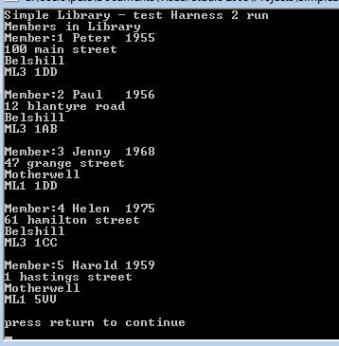
Date Test Run ________________________
Test Passed / Failed ________________________
Name of tester ________________________

Attach a copy of the output from your program that should be similar to the one above.

Test Harness 3.
Expected Output on Console
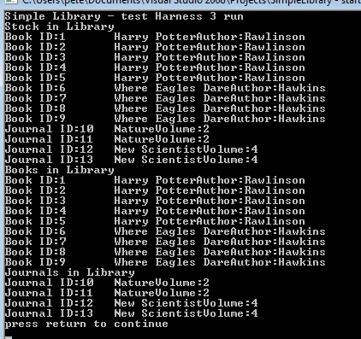
Expected output in text file testharness3output.txt
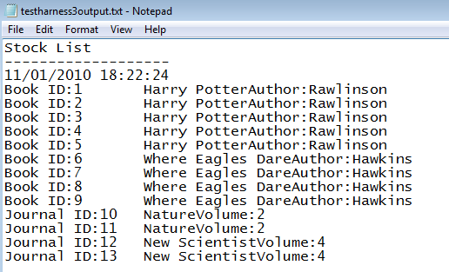
Date Test Run ________________________
Test Passed / Failed ________________________
Name of tester ________________________
Attach a copy of the outputs from your program that should be similar to the ones above.

Test Harness 4.
Expected Output on Console
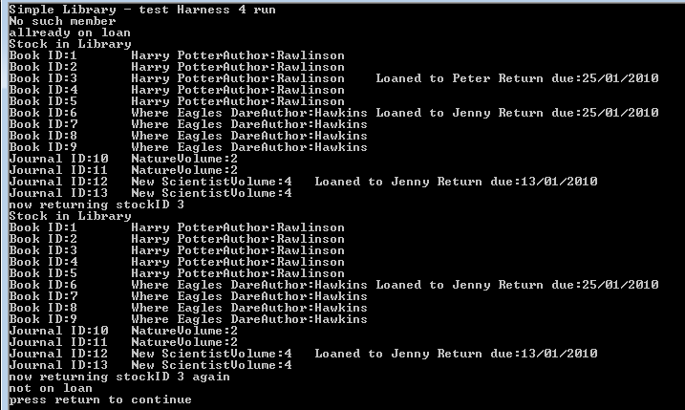
Expected output in text file testharness3output.txt
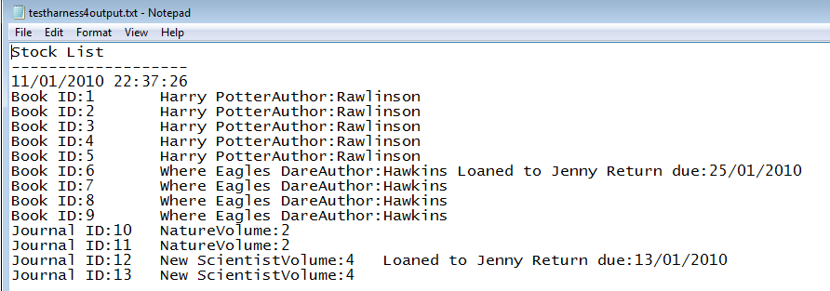

Date Test Run ________________________
Test Passed / Failed ________________________
Name of tester ________________________
Attach a copy of the outputs from your program that should be similar to the ones above.

Partial Acceptance Test (should be run as one continuous test)

 | Description | Expected Result | Comments | Test Pass/Fail
1 | AddMember  Add a member with name “Peter” , street “Watling Street”, town “Motherwell” , and postcode “ABC12345” | Error message must have year of birth
2 | AddMember  Add a member with street “Watling Street”, town “Motherwell” , year 1956 and postcode “ABC12345” | Error message must have name
3 | AddMember  Add a member with name “Peter”, town “Motherwell” , year 1956 and postcode “ABC12345” | Error message must have street
4 | AddMember  Add a member with name “John” , street “Watling Street”, year 1964 and postcode “ML1234” | Error message must have town
5 | AddMember  Add a member with name “John” , street “Watling Street”,town “wishaw” year 1964 and postcode “ML234” | Error message postcode must be between 6 and 8 characters
6 | AddMember  Add a member with name “John” , street “Watling Street”,town “wishaw” year 1964 and postcode “ML1234578” | Error message postcode must be between 6 and 8 characters

Acceptance test page 2

 | Description | Expected Result | Comments | Test Pass/Fail
7 | AddMember  Add a member with name “John” , street “Watling Street”,town “wishaw” year 1964 and postcode “ML1234” | Member created with next available ID
8 | AddMember  Add a member with name “Fred” , street “Watling Street”,town “wishaw” year 1964 and postcode “ML123456” | Member created with next available ID

Date Test Run __________________________ Test Passed/Failed ________________________

Name of Tester: ____________________________

